**CHARTING THE COURSE OF INNOVATION: A STARTUP ANALYSIS**

**1.INTRODUCTION:**

Starting a new company and developing technology requires the clearest visions. Analysis for the startups will help the new one who is looking forward to start a startup company. In our project “CHARTING THE COURSE OF INNOVATION: A STARTUP ANALYSIS” we successfully analysed and now we have a clear vision on startups. This project will help the peoples who is going to start a startups and it will give them a detailed and sophisticated knowledge on startups.

**2.PROBLEM DEFINITION & DESIGN THINKING**

**2.1EMPATHY MAP**

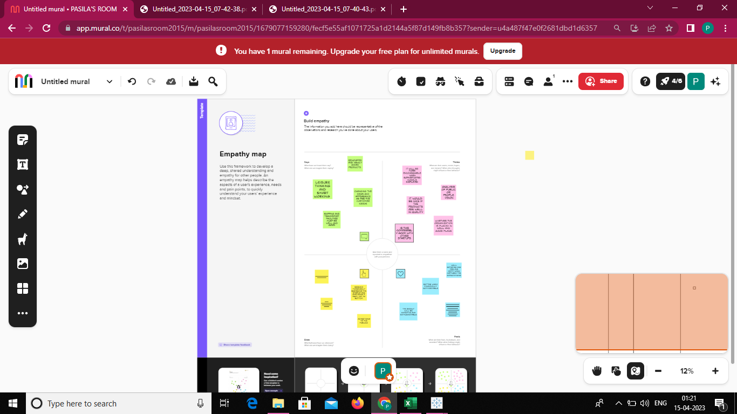

**2.2 IDEATION & BRAINSTORMING MAP**

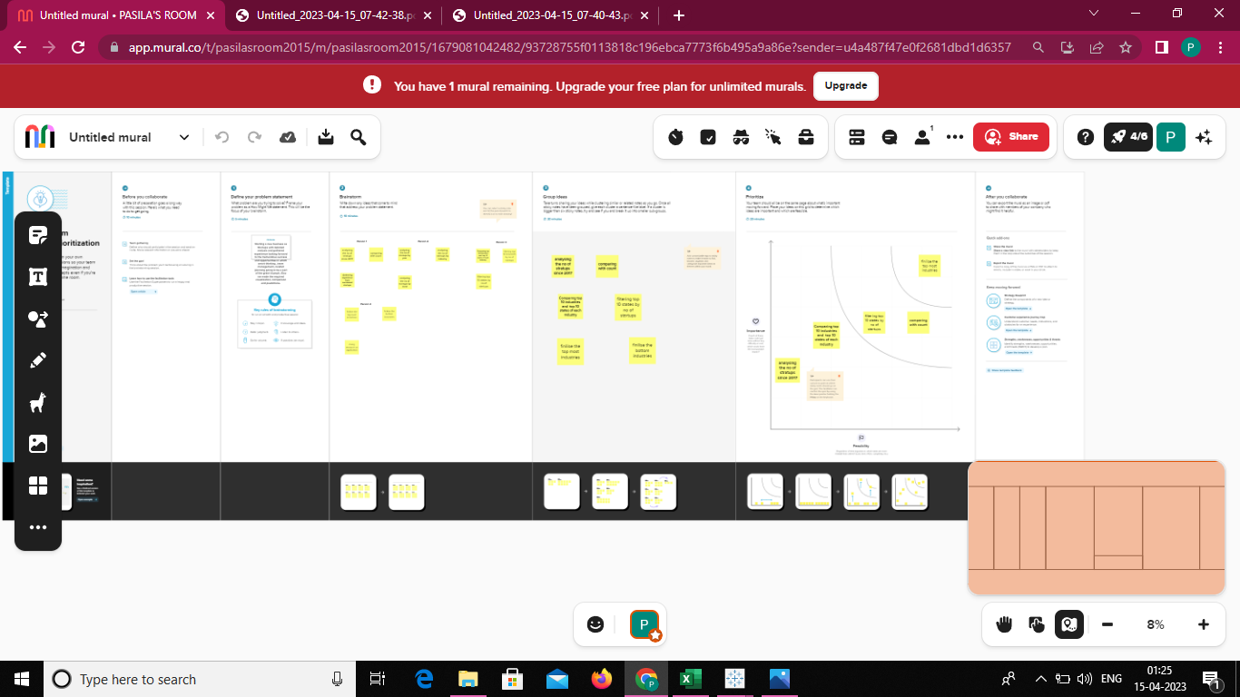

**3. RESULT**

By this analysis, the result that we found is IT SERVICES industry occupied the first place and last place occupied by Passenger experience industry by count and the city Maharashtra occupied first position and the city Mizoram occupied last position by states.

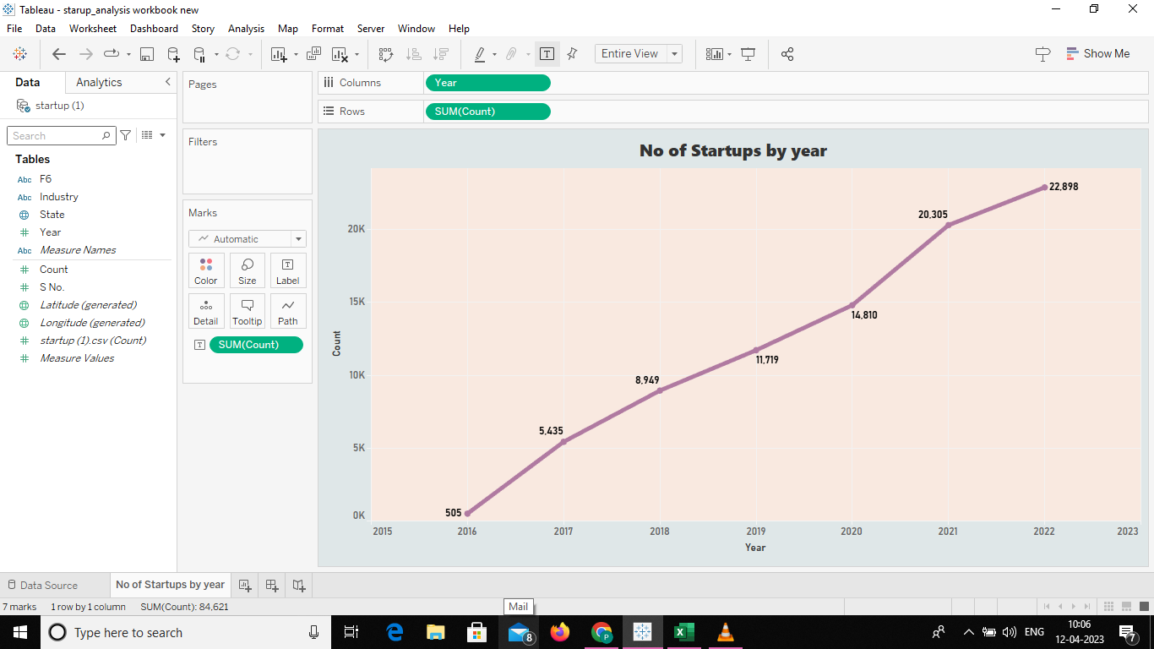

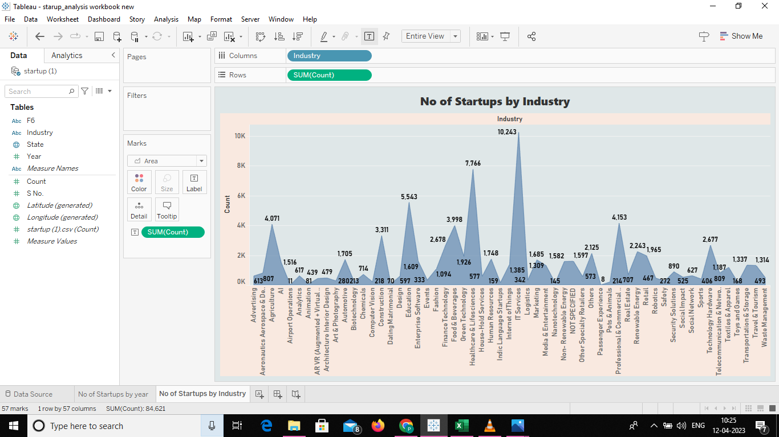

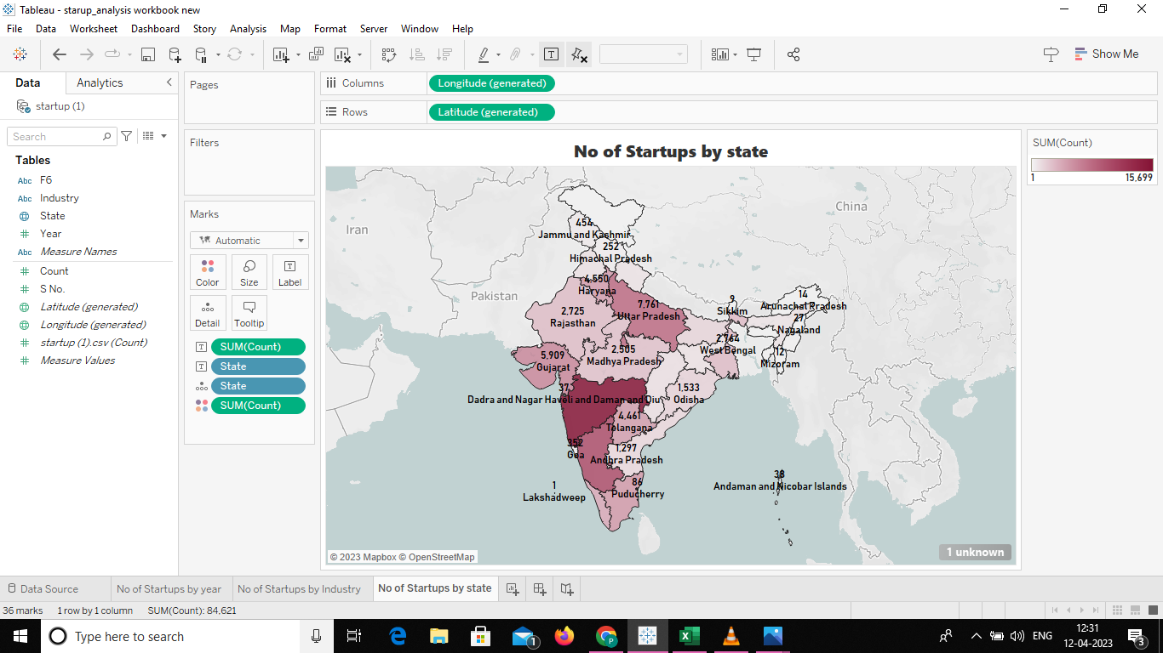

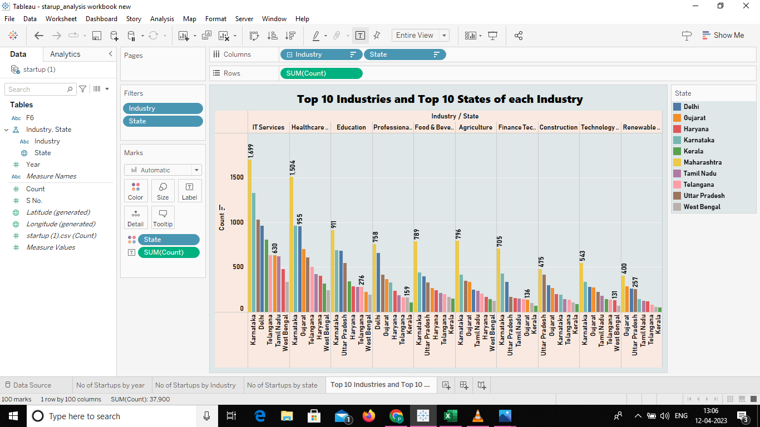

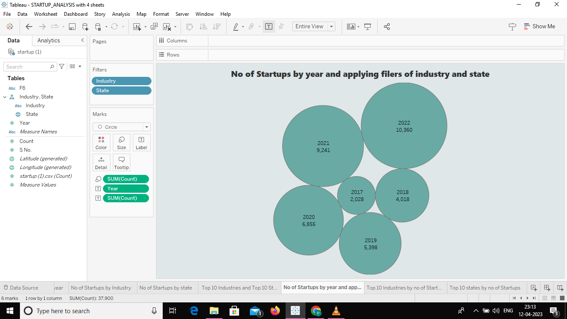

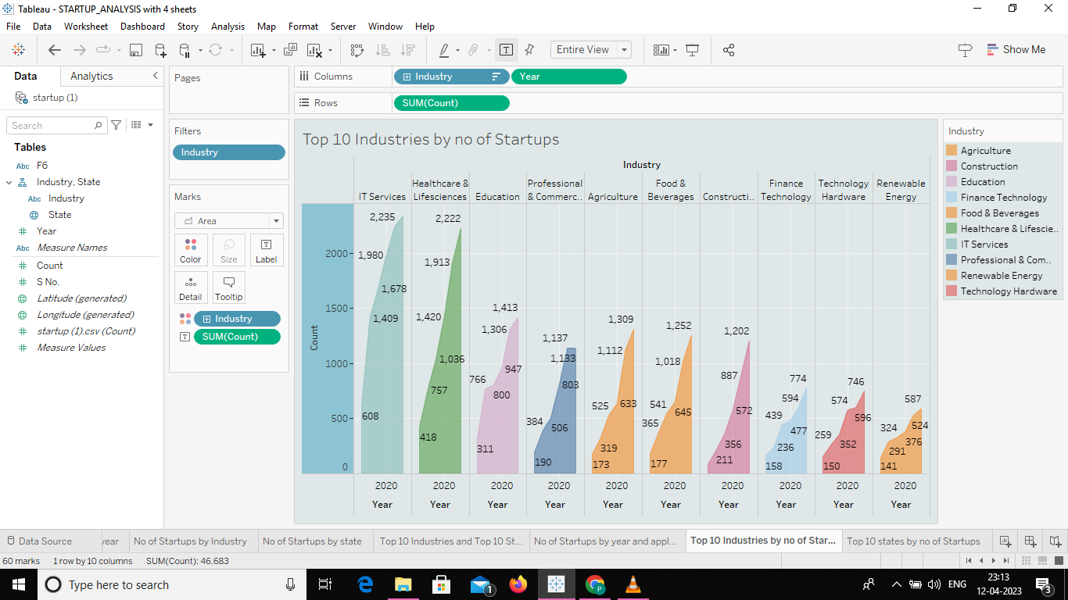

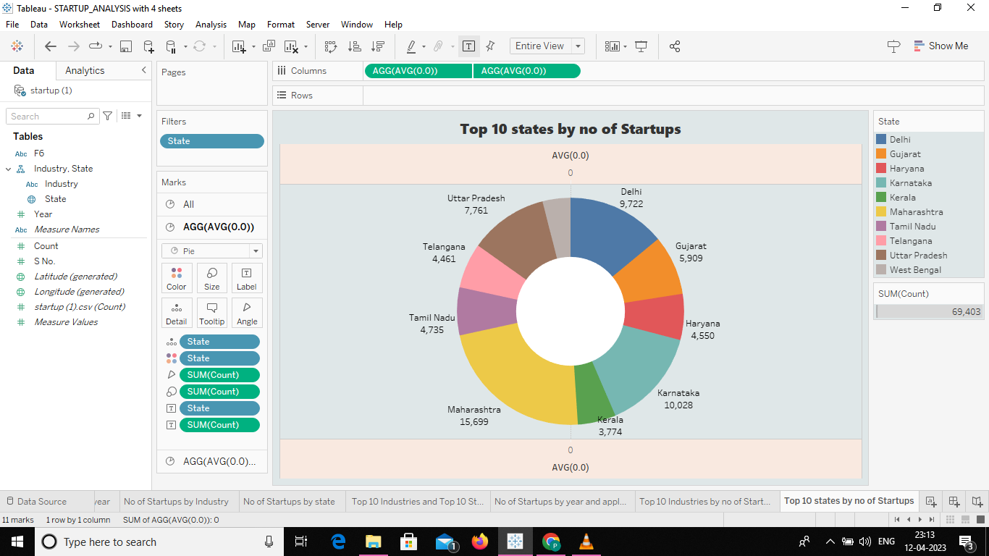

**4. ADVANTAGES AND DISADVANTAGES:**

**ADVANTAGES:**

### Efficiency:

Established companies have high administrative overheads. Startups offer their services in a more efficient, cost-effective and competitive manner. They are likely to be aware of their limitations and tend to focus on their core strengths. This causes them to partner with other small organizations. Customers often benefit with a superior value proposition.

### Team Culture:

Employees of large corporations get attracted by prestige and big salaries. They easily lose sight of the company’s vision, mission and values and the success of its customers. Startup employees form a close-knit community that shares passion, beliefs, and values. They must work together for the good of the company, its customers and the world at large.

### Flexibility

Your organization could have rather unique needs and demands for products and services. These might not be met by established service providers operating in a rigid manner. Startups are very flexible and are more likely to work at the hours, the place and in the manner that suits you.

**DISADVANTAGES:**

### Market Access

Many customers prefer a business that they have worked with over a new startup. Besides it is more expensive to acquire new customers than to retain old ones. Without a customer base, understanding market needs also becomes a real struggle. All these factors combined increase the cost of business development for startups.

### Team Composition

Some startups are born out of desperation since the founder could not find or hold on to a job. Such founders often struggle to build a team that the business needs to succeed. A successful startup requires founders/co-directors with complementary personalities and competencies. Even then disagreements can creep in when the going gets tough.

### Resources

Growth hacking, cloud computing, and venture capitalism allow startups to gain market entry. Most startups operate on a shoestring budget, against competitors that are well-resourced. It gives the competitors an edge in product development, sales, and marketing. They use that edge to push startups out of the market when they become a threat.

**5. APPLICATIONS:**

* This project solution can be used in academic researches
* It can be used in the field of probability
* can be used by the youngsters who is researching to start a startups

**6. CONCLUSION:**

After this successful project completion, we have well good knowledge on Tableau desktop, tableau public, Web integration and web designing. As we are in final year and seeking for good profession, this project have shown a clear thought on startups.

**7. FUTURE SCOPE**

By this project analysis we can able to predict that in future, IT services industry will play a major role by industries. By city, Maharashtra will contribute a big role in Startups.

**8.APPENDIX**

file:///C:/Users/ELCOT/Downloads/Startup%20analysis/Charting%20the%20Course%20of%20Innovation_%20A%20Startup%20Analysis/index.html